"For we are the handiwork of God, born in Christ Jesus to do good works that God has pre-planned for us to do" Ephesians 2:10

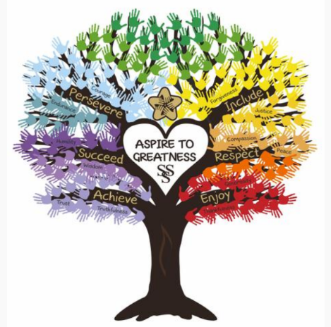

St Stephen’s C of E Primary School

RE Policy - January 2020

At St Stephen’s CE Primary School, Religious Education is an integral part of our school life. We are a Voluntary Controlled Primary School and, as such, Christianity forms the basis of all the teaching in the school and how we treat each other. Religious Education enables children to investigate and reflect on some of the most fundamental questions asked by people. We aim to develop the children’s knowledge and understanding of the major world faiths, and try to address the fundamental questions in life, for example, the meaning of life. By the time our children leave in Y6 we hope they will be enabled to develop a sound knowledge of Christianity and other world religions and the power and importance of prayer. Children reflect on what it means to have a faith and to develop their own spiritual knowledge and understanding. We help our pupils learn from religions as well as about religions and as a reflection of our diverse school community we encourage the children to look for shared values as often as possible.

Mission Statement for RE
Recognising its historic foundation, the school will preserve and develop its religious character in accordance with the principles of the Church of England and in partnership with the churches at parish, diocesan and circuit level. Recognising the multi cultural or multi faith nature of its community, the school aims to serve the surrounding area and people by providing an education of the highest quality within the context of Christian belief and practice. It encourages an understanding of the meaning and significance of faith and promotes Christian values through the experience it offers to all its pupils.

School Context
St Stephen’s is a voluntary controlled school and so is required by law to provide RE in accordance with the Lancashire Agreed syllabus although the Diocesan material is used for the teaching of Christianity and at Special Christian celebrations such as Harvest, Advent, Christmas, Holy Week, Easter.
Although RE, SMSC, British Values and Collective Worship naturally compliment and enrich one another, they are managed separately and all have their own policies and guidance.

Aims of RE
Religious education at St Stephen’s School aims to:

· Give children opportunities to apply their understanding of Christianity to make reasoned and informed responses to life issues and moral choices.
· Develop knowledge and understanding of other principal religions especially those represented in our local and school community.
· Develop sensitivity and respect towards all people no matter what their beliefs.
· Develop the ability to reflect on and communicate with others about issues of truth, belief and faith.
· To explore a personal quest for meaning.
· Develop knowledge and understanding of the Christian faith through a study of the key questions as detailed in our syllabus.

Teaching and Learning - Teaching methods

· Children will be taught RE in a way that is appropriate to their age, needs and learning styles.
· Learning intentions and objectives will be shared with the class or groups and success criteria and assessment opportunities (expectations about outcomes) made clear.
· Linking current learning to previous learning is essential.
.Teachers will place emphasis on children’s spiritual development.

Skills.
Important skills developed during planned learning include:
reflection, empathy, communication and enquiry. Emotional attitudes developed during learning include: respect, sensitivity, open-mindedness and self-esteem. RE learning will be recorded in a range of forms appropriate to the learners and learning planned. Examples might include photos with comments, individual class books, reflections in the class bib books, art work, music, written work, recorded examples of drama using see saw and other apps.Teachers will incorporate computing into RE lessons whenever it enhances the teaching and learning. Experiences to places of religious interest and shared with visitors are encouraged as they give children a greater insight and understanding.

Time Allocation
RE is taught weekly for at least 5% of the curriculum time. This is not always whole class teaching and, where appropriate, can be linked to other subjects. RE learning objectives will be made explicit when learning is linked to other subjects.

Classroom environment and resources

Where appropriate, RE learning is shared in the form of display and samples of the children’s work are recorded and annotated in their class RE journal or individual book- this is used for in house moderation as well as celebrating and show casing children’s attainment.
Resources are routinely audited and purchases made to ensure the quality of resources available to support teaching and learning. Resources are stored in the KS1 area in the cupboards under the worship display and new resources are discussed in briefings and team meetings. Teachers are asked to inform the RE subject leader if they notice that there is a resource need. RE support material is installed on the school’s network (teacher shared drive) to allow teachers and children access. RE has its own capitation and there is regular opportunity for training & professional development for adults and children.

Planned learning and Cross Curricular Links

RE is planned so that each year group studies Christianity (for 60% of the curriculum) and two other faiths over the course of the year. Medium term plans are adapted from the Lancashire Agreed Syllabus for non-Christianity units and Christianity units by the Blackburn diocese syllabus, supplemented by the resource ‘Understanding Christianity. Adaptations are made as appropriate by both the RE subject leader and by class teachers. Some Governors are involved in certain aspects of teaching RE and at times come to speak to the children and share Christian Messages and traditions such as Baptism, Communion and the role of clergy.

Assessment

Class teachers may use success criteria and use the assessment grids on the syllabus to regularly assess against so children know where they are and where they need to go next in their learning. These judgements are moderated between staff and by the RE leader and are recorded at the end of each topic on the assessment drive and a judgement is made in the Summer term and recorded on the Lancashire pupil tracker.

Reporting on RE attainment
Teachers communicate RE achievement once a year in a written school report (summer) and report attainment at Y2 and Y6 to SACRE.

Monitoring

The RE subject leader is responsible for monitoring the subject throughout the school. The RE subject leader provides support on an informal basis where requested. Support is given on a more formal basis where monitoring shows this is necessary or where staff have identified a personal need for professional development. The RE subject leader uses information collected during monitoring to plan future development through the process of yearly action planning.

Equal Opportunities

Access to the RE curriculum will be provided to all pupils of the school irrespective of age, gender, race and ability. When examining religious issues; beliefs and customs of others will be respected.

Parents Right of Withdrawal

Parents have the right to withdraw their children from
Religious Education and collective worship as identified in the
Education Action 1944 and in subsequent legislation. St Stephen’s is a C of E Primary School where Christian values and principles underpin the whole curriculum. In order to preserve the distinctiveness of this church school community we encourage everyone to be involved in the RE. Parents who have concerns about this should contact the Head Teacher.

