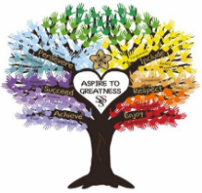

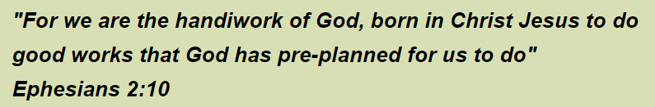

How do we plan for spirituality at St Stephen’s CE School?
Spirituality Moral Social Cultural (SMSC) opportunities are planned as a whole school and reflected on our curriculum overviews- WOW writing and courageous advocacy opportunities.
Incidentals (awe and wonder opportunities such as snow days, Theatre trip, knitted Bible exhibition), enrichments (Easter, Eid, Holi, Diwali, Parliament wk) and topical events (such as RSPB big bird watch, sports relief, Fairtrade)

- Spiritual capacity- recognition that all human beings are capable of spiritual growth through capacities such as self-awareness, reflection, empathy, imagination and creativity

How is this shown?
Behaviour- allowing children time to just BE, nurture- journeying moments together, reflection in the ‘nest’ at lunchtimes- an opportunity to talk or be quiet.
PSHE about self awareness- ‘understanding me and others’.
Christian values such as respect and ASPIRE.
Go Noodle and breathing exercises for stillness.
Children involved in courageous advocacy, use of picture news, children stand by their beliefs- eg fasting during Ramadan, opportunities to pray with staff/pupils, wearing religious items of clothing, staff and children actively showing and accepting forgiveness, children supporting others-buddies, new arrivals, social stories, children with SEMH, restorative justice- what does it feel like to walk in someone else’s shoes?

- Spiritual Experiences: ways in which pupils can encounter the spiritual dimension of life

How is this shown? Places of worship visits, reflection area in class, prayer spaces around school, times to reflect in class/school worship, outdoor learning (awe and wonder) within curriculum and outside of curriculum (whole school and class ) worship, Tues forest school KS1 group, community events), enjoyment (E in ASPIRE), opportunities to be creative and imaginative and experiencing wow in learning

- Spiritual Understanding: the need to have developed an understanding to make sense of the spiritual experiences encountered and capacities exercised

How is this shown? Children are encouraged to ask and answer big questions not just in RE and worship but across the curriculum. Our children are able to make links between faiths and beliefs and there is a culture of openness between children and staff. On visits and when visitors come in, children have time to prepare and then reflect.

- Spiritual responses: how this experience and understanding impacts on our lives and shapes the way in which we live our lives.

How is this shown? Staff talk to children and children talk to children about wow moments and how it shapes decisions and life choices. Some children have marvellous moment books to formally record experiences and impact. Children are given opportunities to reflect not only on their behaviour but on their learning. AFL, marking and feedback has placed more emphasis on children reflecting on next steps alongside peers and the teacher, praying for each other- staff sickness, bereavements, staff pregnancy. Matthew 22:v 34-40 (We sing it in worship and live it!)

A quick guide to St Stephen’s CE School’s philosophy on Spirituality

Spirituality can be seen as windows, mirrors and doors:

WINDOWS- Staff and children looking out on the world -seeing the good and bad

MIRRORS- Providing an opportunity to look in and self reflect, share ideas

DOORS- Stepping out, taking actions, changing attitudes, behaviour or thinking

